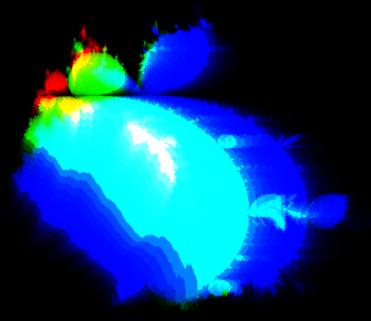
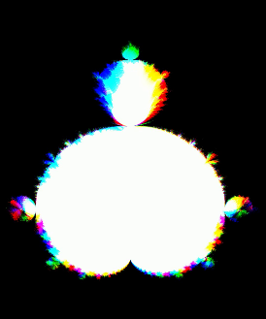
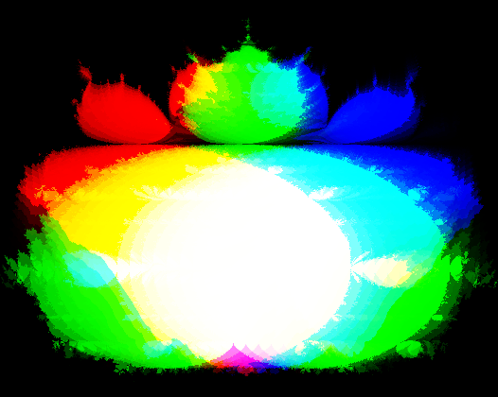
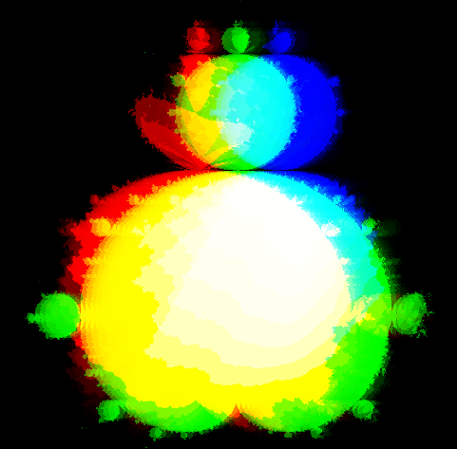

XYTC Marc
Dunand

Most higher-dimensional visualization techniques compress or warp four-dimensional data to “fit” into three dimensions. I propose XYTC, a novel visualization technique that can represent any four-dimensional structure losslessly.
XYTC follows from how the human eye perceives. Our retina detects where light strikes on its two-dimensional surface, giving us 2D vision. However, the retina also detects a third dimension: color. It perceives three independent units of information for every photon: X, Y, and wavelength. By the definition of independence, each can be treated as its own dimension.
Perception takes place in the mind, which perceives one additional dimension: time. Like color, time can be reparameterized as another spatial dimension.
We now have four independent dimensions: where the photon strikes the retina (X, Y), when the photon strikes the retina (T), and what color the photon is (C). XYTC is crafted like a key to the lock of human visual perception. It makes full use of every perceivable dimension. Nothing is wasted; every channel contains data.

XYTC enables interactive navigation of its four-dimensional space. As a demonstration, it renders the Julia–Mandelbrot set, a complex four-dimensional fractal generalization of the two-dimensional Mandelbrot set. The result functions as both interactive artwork and as visualization technique, letting viewers explore the fractal’s stunning self-similarity while losslessly encoding four-dimensional data.

I am conducting a study with Professor Elena Glassman measuring the efficacy of XYTC versus other 4D visualization techniques. See a draft of the paper. For outreach, I am collaborating with educational YouTuber Purplemind on a video about XYTC. See our past research outreach collaboration.
With ever-expanding higher-dimensional AI datasets and a mounting need for beautiful and accessible research communication, I believe XYTC is a salient tool for researchers, artists, and designers.

Funding will support subcontracted animations for the video, participant incentives for the study, and a final generative XYTC installation that shifts through 4D space (see demos below), with scope scaling to available funds.

___________________________________________________________________________________________

Download XYTC View Draft Paper Watch Demo #1 Watch Demo #2

